ASSESSMENT
C01-ASSISSMENT TOOL-1
CONCEPT MAP
NAME:P ROHINI COURSECODE: CSA0307
REG NO:192524147
COURSE NAME: DATASTRUCTURE

- Employee Management system

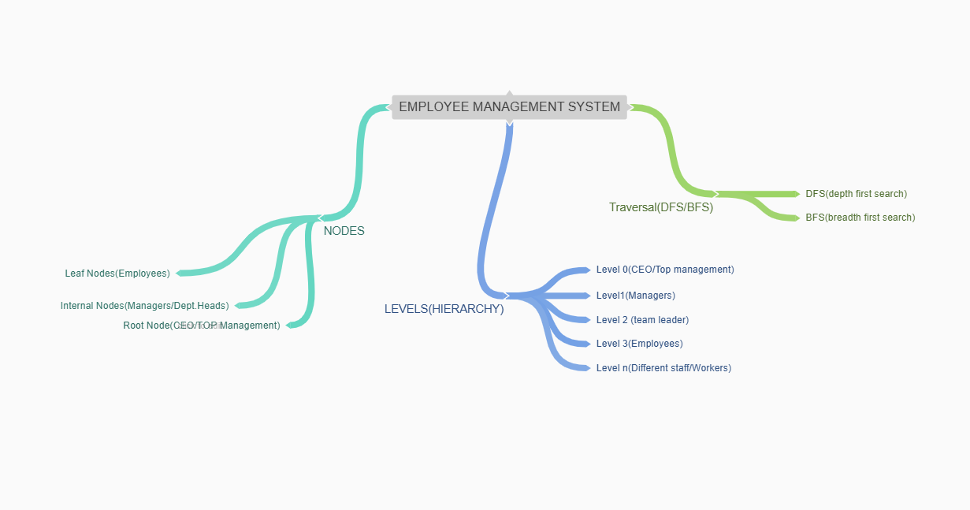

2)Logistics Company

